**Customer Participation Rate in Group Deals**

**Definition:**

The **Customer Participation Rate** measures the percentage of unique users who participate in group deals (by adding items to group carts) compared to the total number of users in the system. It provides insights into customer engagement and the appeal of group deals as a business strategy.

**Formula:**

Customer Participation Rate (%)=Distinct Users in Group CartsTotal Users×100\text{Customer Participation Rate (\%)} = \frac{\text{Distinct Users in Group Carts}}{\text{Total Users}} \times 100

**SQL Query:**

The following SQL query calculates the total number of users, the number of unique users participating in group deals, and the participation rate as a percentage:

SELECT

(SELECT COUNT(*) FROM public.users) AS total_users,

(SELECT COUNT(DISTINCT user_id) FROM public.groups_carts) AS distinct_users_in_cart,

ROUND(

(SELECT COUNT(DISTINCT user_id) FROM public.groups_carts)::decimal /

(SELECT COUNT(*) FROM public.users) * 100, 2

) AS participation_rate

;

**Importance**

1. **Measures Engagement**:
   * Indicates how many users are interested in and actively participating in group deals.
2. **Informs Strategy**:
   * A high participation rate suggests that group deals are effectively engaging customers.
   * A low rate could highlight the need for better marketing or adjustments to the group deal structure.
3. **Supports Business Decisions**:
   * Helps stakeholders understand customer behavior and refine group deal offerings to boost engagement.

**Charts**

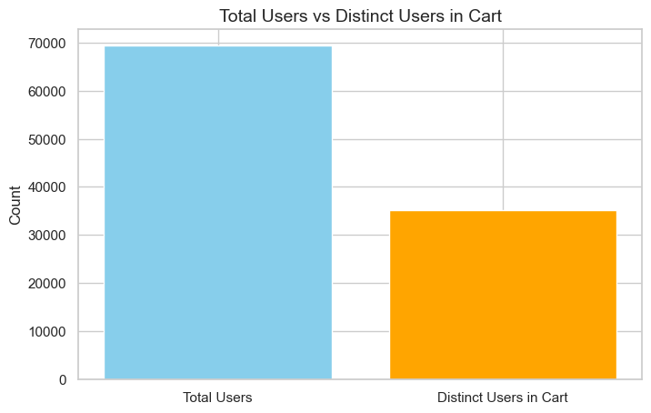

* **Total Users** is represented by a blue bar, which appears significantly taller, indicating a larger count.
* **Distinct Users in Group Cart** is represented by an orange bar, which is shorter, suggesting that not all users Add item to Group Carts.

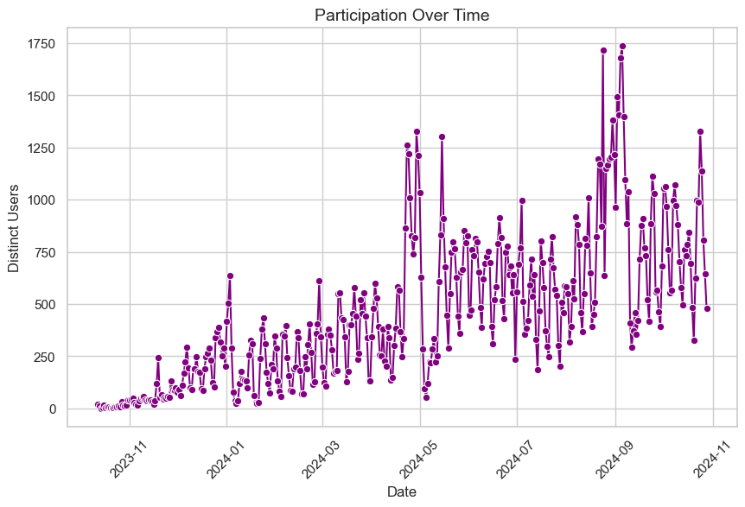

In The Above chart

* The **x-axis** represents time, specifically from November 2023 to November 2024.
* The **y-axis** indicates the number of distinct users participating.

Key observations are

* There are noticeable fluctuations in participation, with some peaks indicating higher activity at certain points.
* The general trend appears to show an increase in participation over time, especially in specific months.
* The presence of spikes suggests occasional bursts of activity, which could be linked to events, promotions, or other factors influencing user engagement.

Overall, the graph illustrates the changing levels of user participation over the specified time period it’s not Fixed thing .